ECCC Office Capacity Dashboard

User Guide

ECCC Office Capacity is a dashboard report, created by RTW project team, to analyze the office capacity by visualizing the capacity of ECCC buildings (floors) and the employee’s access requests.

In order to use the ECCC Office Capacity dashboard, the user will need to:

1. Install Power BI desktop (from “Software Center”)

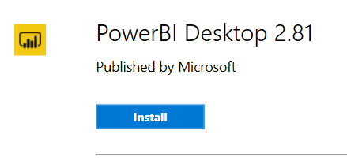

1. Get permission to “ECCC Office Capacity Dashboard”

Contact the Service Desk and ask for the “RLT-RTW ECCC Office Capacity Dashboard” permission.

* Service Desk will assign the ticket to the Real Property Management team
* The Real Property Management team will review the request and set up the user’s permission

(Add a user into the SharePoint group of “Dashboard Readers” for the SharePoint site “Retour au Lieu de Travail - Return to the Workplace”)

1. Download the “*ECCC Office Capacity.pbit”* file from [here](https://ecollab.ncr.int.ec.gc.ca/org/11001/CSFBCollaboration/ECCC%20Office%20Capacity.pbit)

“ECCC Office Capacity” dashboard is in English. Please refer to “ECCC Capacité des bureaux - Guide d’utilisation” for the dashboard in French.

User Manual

1. Run PowerBI Desktop, open the ECCC Office Capacity.pbit file 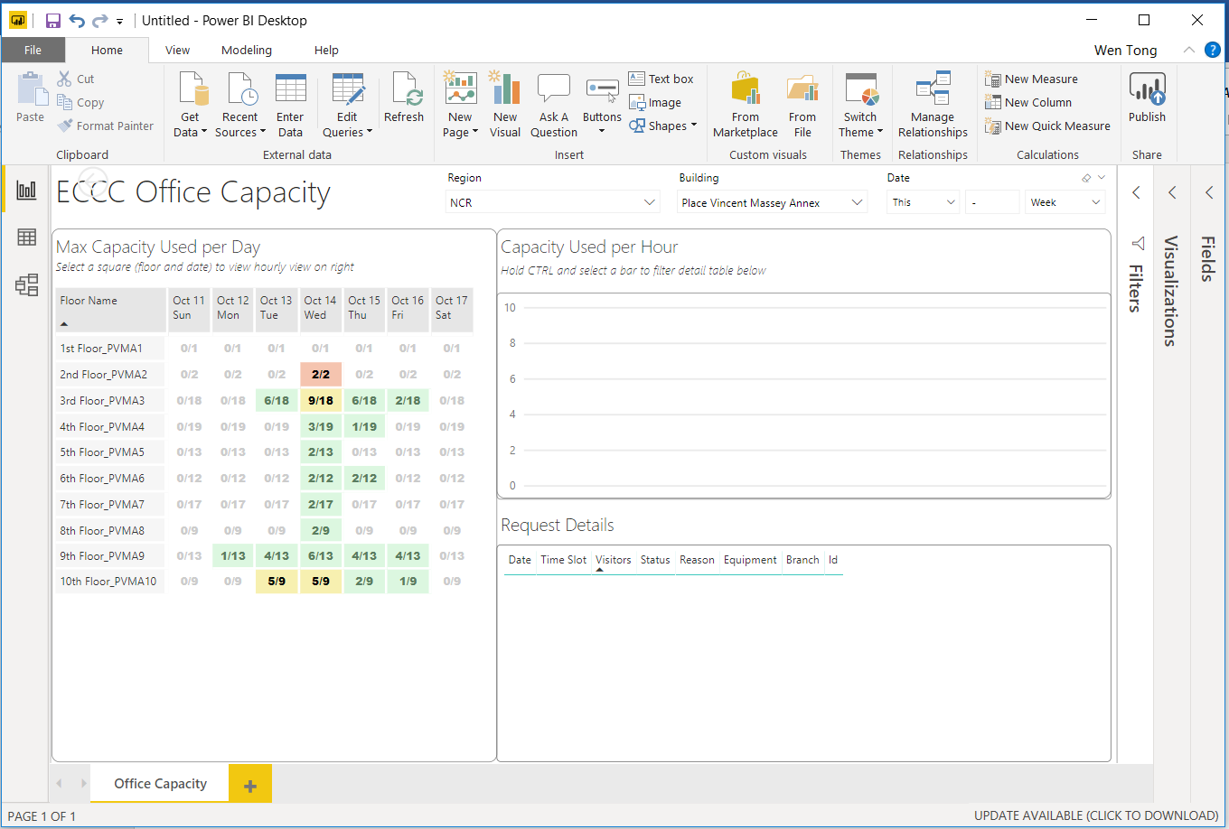
2. Connect to the SharePoint list

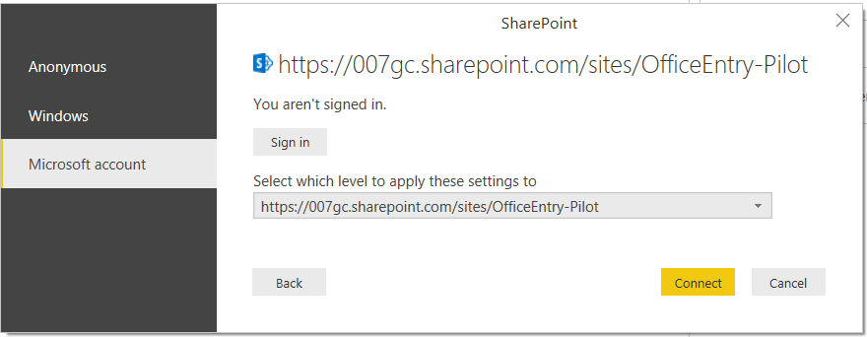

When user open the dashboard for the first time, user will be prompted to connect to the SharePoint list. User needs to make sure that the SharePoint permission has been set (refer to “*Get permission to ECCC Office Capacity Dashboard”).*

* The SharePoint site is displayed as the data source,

<https://007gc.sharepoint.com/sites/RapportdeRetourauLieudeTravail-ReturntotheWorkplaceReporting/>

**while the above image shows the Pilot site

* Select the *Microsoft account* from the left menu
* *Sign in*

Use your M365 account, [*FirstName.LastName*@ec.gc.ca](mailto:FirstName.LastName@ec.gc.ca), to sign in

* *Select which level to apply these settings to*

<https://007gc.sharepoint.com/sites/RapportdeRetourauLieudeTravail-ReturntotheWorkplaceReporting/>

* *Connect*

Once connected to the SharePoint list, dashboard will refresh the data; it may take a few seconds to load.

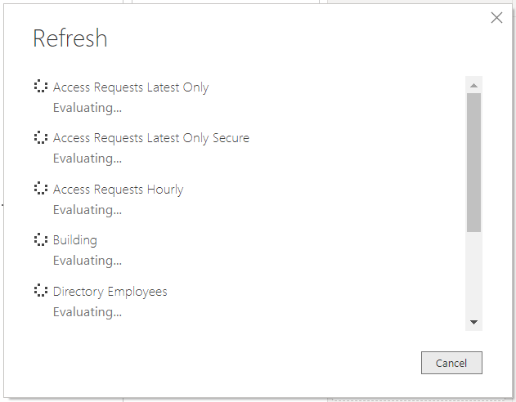

1. Select Region, Building and Date

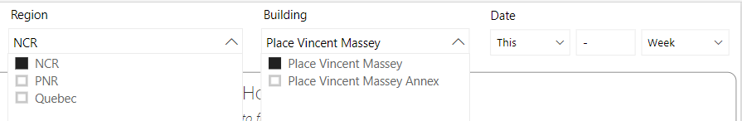

1. Three sections, “Max Capacity Used per Day”, “Capacity Used per Hour”, “Request Details”

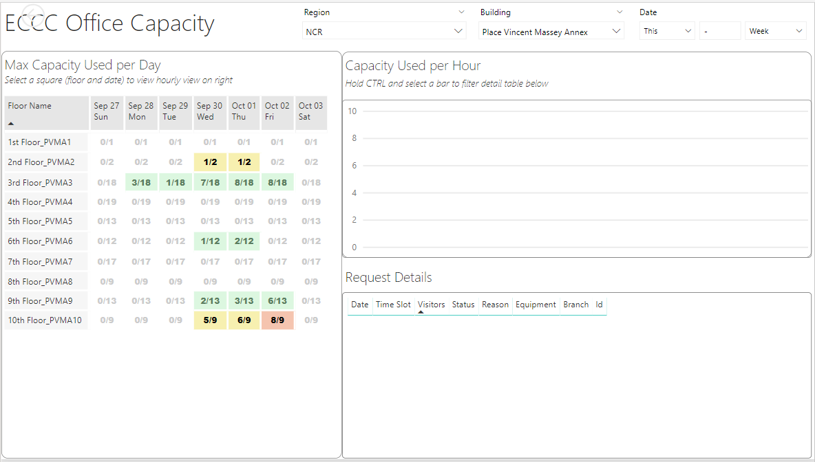

** *7/18* means,

1. the capacity is 18 for that floor (3rd Floor of PVMA building)
2. there are maximum of 7 employees (and visitors) on that floor during that day (Sep 30 Wed)

*** Color represents the ratio of the access requests over the floor capacity.

* Green: less than 50%
* Yellow: 50% ~ 80%
* Coral: 80% ~ 100%

1. Select a Floor and a Day-Of-Week in the “Max Capacity Used Per Day”

The “Capacity Used per Hour” and the “Request Details” will show accordingly

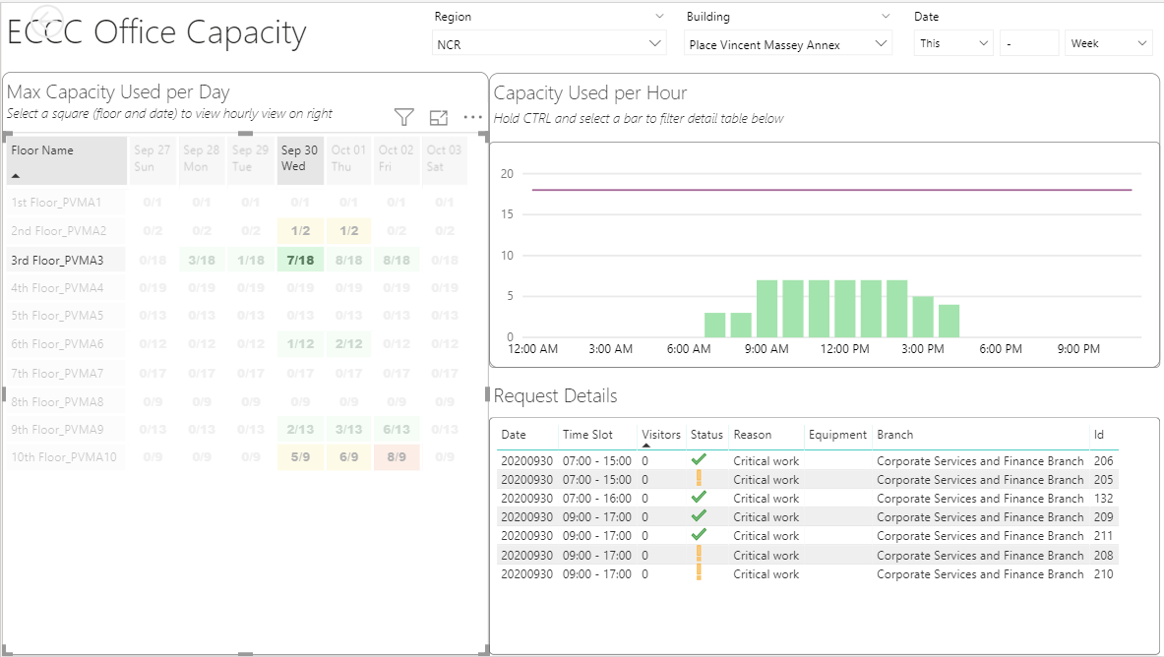

1. Select a time slot in the “Capacity Used per Hour” *(Hold CTRL and select a bar to filter detail table)*

The “Request Details” will show Date, Time Slot, Visitors, Status, Reason, Equipment and Branch.

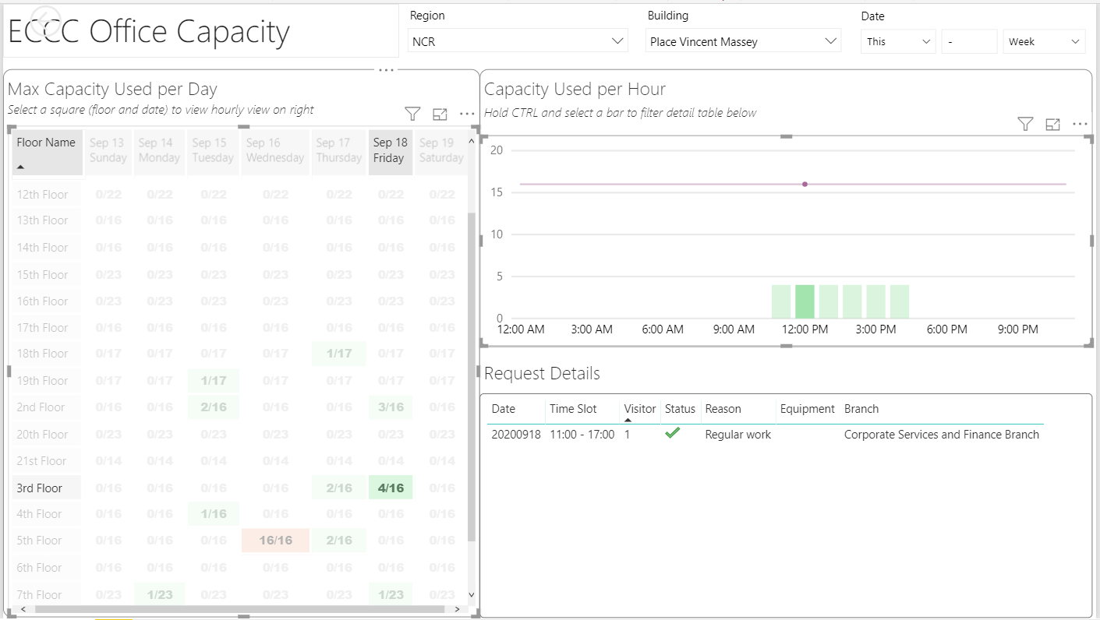

1. User can click the “*Refresh”* button from the menu bar to reload the data into dashboard

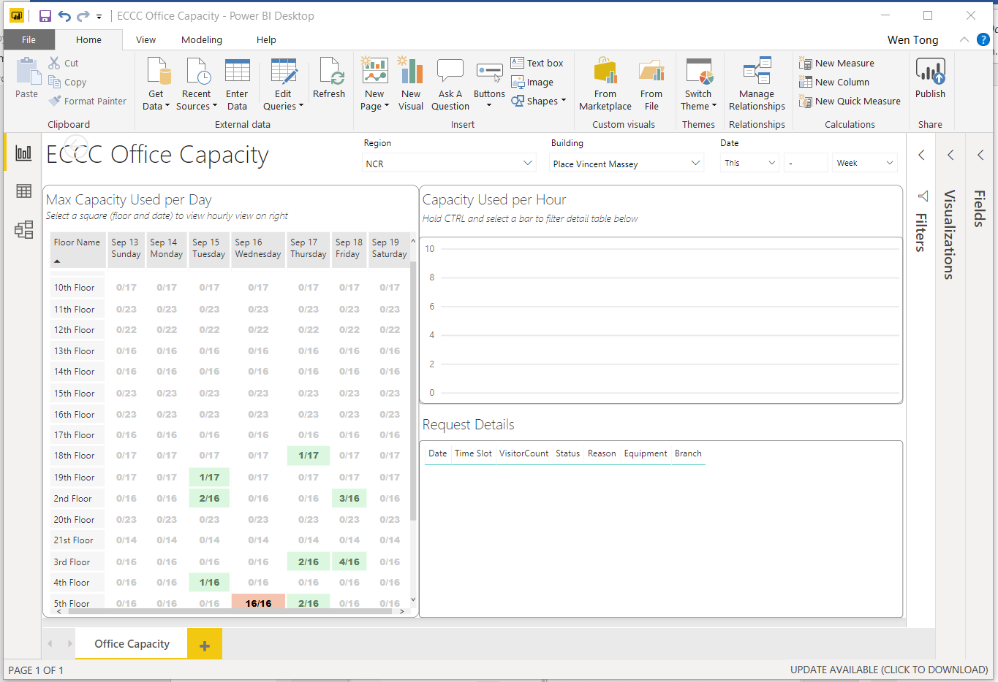

1. Save the dashboard when exit

* User do not need to save the dashboard when exit
* If user has made some change and wish to save the change to the dashboard

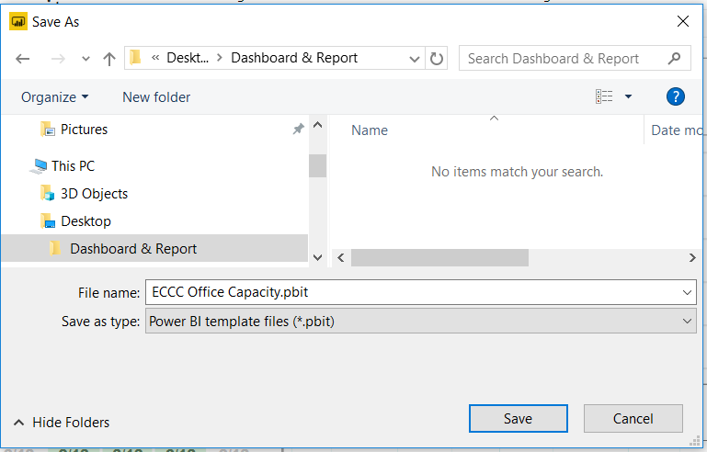

* + *File name*: ECCC Office Capacity.pbit
  + *Save as type*: Power BI template files (*.pbit)